Numeral Systems
# Source: AI Source: Provided by: [Data Path: Persons Table -> ID Column: 1, Name_En Column: Motasem Essam] -> From: [ChatGPT] on [7/16/2026]
A Numeral System is a method of representing numbers using symbols according to specific rules. Different numeral systems use different sets of symbols (digits) and different positional values (bases or radices) to express numerical values.
Numeral systems are fundamental to mathematics, computer science, engineering, digital electronics, cryptography, and everyday arithmetic.

Definition
# Source: AI Source: Provided by: [Data Path: Persons Table -> ID Column: 1, Name_En Column: Motasem Essam] -> From: [ChatGPT] on [7/16/2026]
A Numeral System is a structured method for writing, reading, and representing numbers using one or more symbols according to defined mathematical rules.
A numeral system specifies:
- The symbols (digits) used.
- The base (radix) of the system.
- The positional value of each digit.
- The rules for representing numbers.

Number vs. Numeral
# Source: AI Source: Provided by: [Data Path: Persons Table -> ID Column: 1, Name_En Column: Motasem Essam] -> From: [ChatGPT] on [7/16/2026]
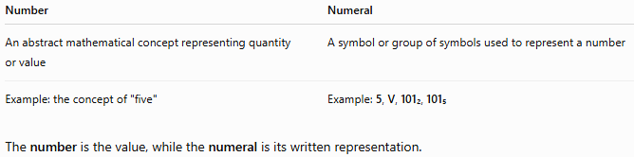
Number | Numeral
An abstract mathematical concept representing quantity or value | A symbol or group of symbols used to represent a number
Example: the concept of "five" | Example: 5, V, 101₂, 101₅
The number is the value, while the numeral is its written representation.

Components of a Numeral System
# Source: AI Source: Provided by: [Data Path: Persons Table -> ID Column: 1, Name_En Column: Motasem Essam] -> From: [ChatGPT] on [7/16/2026]
Every numeral system has:
- A base (radix).
- A set of digits (symbols).
- Positional values based on powers of the base.

Base (Radix)
# Source: AI Source: Provided by: [Data Path: Persons Table -> ID Column: 1, Name_En Column: Motasem Essam] -> From: [ChatGPT] on [7/16/2026]
The base of a numeral system is the number of unique digits available before a new place value is introduced.
If the base is $b$, then each position represents a power of $b$.

Positional Numeral Systems
# Source: AI Source: Provided by: [Data Path: Persons Table -> ID Column: 1, Name_En Column: Motasem Essam] -> From: [ChatGPT] on [7/16/2026]
Most modern numeral systems are positional, meaning that the value of a digit depends on:
- the digit itself, and
- its position.
Example (Decimal):
$$352=3×{10}^{2}+5×{10}^{1}+2×{10}^{0}$$

Non-Positional Numeral Systems
# Source: AI Source: Provided by: [Data Path: Persons Table -> ID Column: 1, Name_En Column: Motasem Essam] -> From: [ChatGPT] on [7/16/2026]
Some ancient numeral systems are non-positional.
In these systems, symbol values do not depend on position.
Example:
Roman Numerals
$$X=10$$
where the symbol has the same value regardless of position.

Common Numeral Systems

Decimal System (Base 10)
# Source: AI Source: Provided by: [Data Path: Persons Table -> ID Column: 1, Name_En Column: Motasem Essam] -> From: [ChatGPT] on [7/16/2026]
Base
$$10$$
Digits
$$0,1,2,3,4,5,6,7,8,9$$
Example:
$${548}_{10}$$
Expanded form:
$$5×{10}^{2}+4×{10}^{1}+8×{10}^{0}$$
Applications:
- Everyday mathematics
- Finance
- Commerce
- Science

Binary System (Base 2)
# Source: AI Source: Provided by: [Data Path: Persons Table -> ID Column: 1, Name_En Column: Motasem Essam] -> From: [ChatGPT] on [7/16/2026]
Base
$$2$$
Digits
$$0, 1$$
Example:
$${101101}_{2}$$
Applications:
- Computers
- Digital electronics
- Logic circuits

Octal System (Base 8)
# Source: AI Source: Provided by: [Data Path: Persons Table -> ID Column: 1, Name_En Column: Motasem Essam] -> From: [ChatGPT] on [7/16/2026]
Base
$$8$$
Digits
$$0-7$$
Example:
$${527}_{8}$$
Applications:
- Legacy computer systems
- UNIX permissions
- Digital systems

Hexadecimal System (Base 16)
# Source: AI Source: Provided by: [Data Path: Persons Table -> ID Column: 1, Name_En Column: Motasem Essam] -> From: [ChatGPT] on [7/16/2026]
Base
$$16$$
Digits
$$0-9, A, B, C, D, E, F$$
where
$$A=10, B=11, …, F=15$$
Example:
$$3AF_{16}$$
Applications:
- Programming
- Memory addresses
- Web colors
- Machine code

Roman Numeral System
# Source: AI Source: Provided by: [Data Path: Persons Table -> ID Column: 1, Name_En Column: Motasem Essam] -> From: [ChatGPT] on [7/16/2026]
Roman numerals are non-positional.
Symbols:
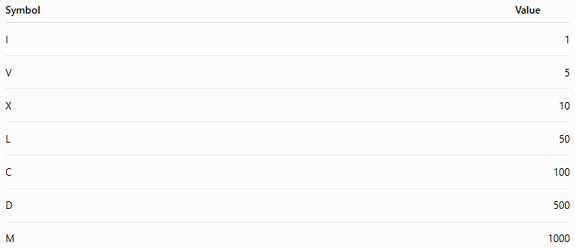
Symbol | Value
I | 1
V | 5
X | 10
L | 50
C | 100
D | 500
M | 1000
Example:
$$MCMLXXXIV=1984$$
Applications:
- Clock faces
- Book chapters
- Monarch names
- Events

Positional Value
# Source: AI Source: Provided by: [Data Path: Persons Table -> ID Column: 1, Name_En Column: Motasem Essam] -> From: [ChatGPT] on [7/16/2026]
For a numeral
$${\left(d_{n}d_{n-1}…d_{1}d_{0}\right)}_{b}$$
its value is
$$\boxed{\sum_{k=0}^{n}{d_{k}}b^{k}}$$
where:
- $d_{k}$is the digit,
- $b$is the base.

Examples
# Source: AI Source: Provided by: [Data Path: Persons Table -> ID Column: 1, Name_En Column: Motasem Essam] -> From: [ChatGPT] on [7/16/2026]
Decimal
$$473=4({10}^{2})+7(10)+3$$

Binary
$${1011}_{2}=1(2^{3})+0(2^{2})+1(2)+1=11$$

Octal
$${245}_{8}=2(64)+4(8)+5=165$$

Hexadecimal
$$2F_{16}=2(16)+15=47$$

Conversion Between Numeral Systems
# Source: AI Source: Provided by: [Data Path: Persons Table -> ID Column: 1, Name_En Column: Motasem Essam] -> From: [ChatGPT] on [7/16/2026]
Common conversions include:
- Decimal ↔ Binary
- Decimal ↔ Octal
- Decimal ↔ Hexadecimal
- Binary ↔ Octal
- Binary ↔ Hexadecimal
- Octal ↔ Hexadecimal

Applications
# Source: AI Source: Provided by: [Data Path: Persons Table -> ID Column: 1, Name_En Column: Motasem Essam] -> From: [ChatGPT] on [7/16/2026]
Numeral systems are used in:
- Arithmetic
- Algebra
- Computer Science
- Programming
- Digital Electronics
- Networking
- Cryptography
- Data Storage
- Engineering
- Scientific Computing

Real-Life Applications
# Source: AI Source: Provided by: [Data Path: Persons Table -> ID Column: 1, Name_En Column: Motasem Essam] -> From: [ChatGPT] on [7/16/2026]
Numeral systems are used in:
- Computer processors (binary)
- File permissions (octal)
- Memory addresses (hexadecimal)
- HTML color codes (hexadecimal)
- Financial calculations (decimal)
- Clock numbering (Roman numerals)
- Digital communication
- Embedded systems
- Robotics
- Networking

Common Mistakes
# Source: AI Source: Provided by: [Data Path: Persons Table -> ID Column: 1, Name_En Column: Motasem Essam] -> From: [ChatGPT] on [7/16/2026]
- Confusing the base with the largest digit.
- Assuming digits have the same value in every base.
- Forgetting that hexadecimal digits A–F represent 10–15.
- Reading binary numbers as decimal numbers.
- Assuming Roman numerals are positional.

Key Points
# Source: AI Source: Provided by: [Data Path: Persons Table -> ID Column: 1, Name_En Column: Motasem Essam] -> From: [ChatGPT] on [7/16/2026]
- A numeral system defines how numbers are represented.
- Modern numeral systems are usually positional.
- The base determines the available digits and place values.
- Decimal is the standard system for everyday use.
- Binary, octal, and hexadecimal are widely used in computing.
- Roman numerals are a common non-positional numeral system.

Comparison of Common Numeral Systems
# Source: AI Source: Provided by: [Data Path: Persons Table -> ID Column: 1, Name_En Column: Motasem Essam] -> From: [ChatGPT] on [7/16/2026]
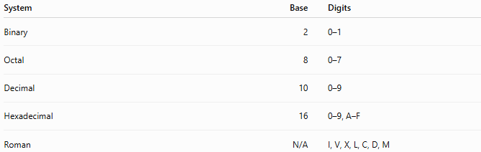
System | Base | Digits
Binary | 2 | 0–1
Octal | 8 | 0–7
Decimal | 10 | 0–9
Hexadecimal | 16 | 0–9, A–F
Roman | N/A | I, V, X, L, C, D, M

Positional vs. Non-Positional Systems
# Source: AI Source: Provided by: [Data Path: Persons Table -> ID Column: 1, Name_En Column: Motasem Essam] -> From: [ChatGPT] on [7/16/2026]
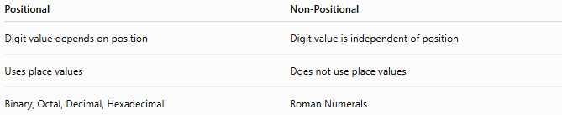
Positional | Non-Positional
Digit value depends on position | Digit value is independent of position
Uses place values | Does not use place values
Binary, Octal, Decimal, Hexadecimal | Roman Numerals

Conclusion
# Source: AI Source: Provided by: [Data Path: Persons Table -> ID Column: 1, Name_En Column: Motasem Essam] -> From: [ChatGPT] on [7/16/2026]
A Numeral System is a structured method for representing numbers using symbols and mathematical rules. Most modern numeral systems are positional, where the value of each digit depends on its position and the system's base. The decimal system is used in everyday life, while binary, octal, and hexadecimal are essential in computing and digital electronics. Understanding numeral systems is fundamental for mathematics, programming, engineering, and modern technology.

